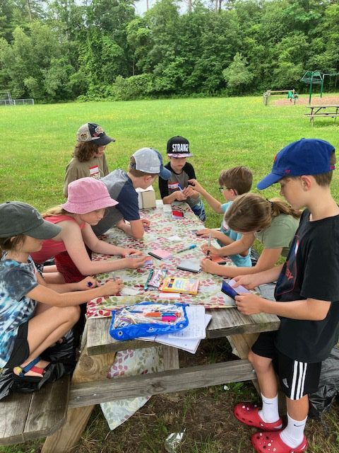
MARION NATURAL HISTORY MUSEUM
HELP WANTED: PART-TIME EDUCATIONAL ASSISTANT FOR AFTER-SCHOOL PROGRAMS

The Marion Natural History Museum is looking for a part-time assistant for our 2025 - 2026 after-school programs. Additional responsibilities may include some Saturday mornings if you’re available. The Marion Natural History Museum is undergoing some substantial upgrades and this position will be helpful on resumes and for references. This is a paying position and programs will be starting soon. If interested, please contact the museum director at Director@marionmuseum.org.

